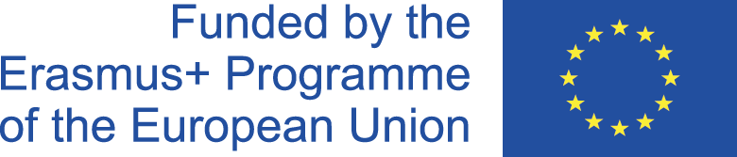
Efficent Usage of Natural resources 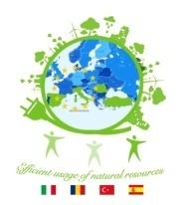

2017-1-RO01-KA219-037131

Efficient Usage of Natural Resources
Transnational Meeting Agreed Actions
Galati, Romania – 26th- 28th of September 2018

During the TPM in Galati the following things have been established:

Organisation of the next project meetings:

It’s been established the next LTTA for Malaga, Spain for 9-15 December 2018
The last TPM in Konya, Turkey: 29th May – 3rd of June 2019 (working days 30th May – 1st of June)

The organisation of the mini- projects:

- First mini project: Finding ways for the efficient usage of natural resources: each country has to send their final form of the material in Word document (7-10 pages) by the 8th of October to Italy (Michele Oliva responsible) and Italy has to send the first draft of the brochure during 1-4th of November. By the 15th of November every partner country has to send their suggestions, corrections, etc.
- Second mini project: Finding ways for recycling (Romania responsible). Each partner country has to send to the Romanian partner photos, short films with objects made from recycled materials and from the flash mob activities by the 1st of December.
- Third mini project: Reducing carbon footprint (Turkey is responsible). Each partner country has to send their final version of a Word document (7-10 pages) to the Turkish partner by the 4th of February.
- Fourth mini project: Photo Competition : (Spain and Italy are responsible). The rules and sections of the contest will be sent to the partner countries by the Italian partner till the 1st of November. Each school will choose 10 photos that will be brought to the LTTA in Malaga.
- Fifth mini project: Shooting a short movie (Turkey is responsible). Each country has to make a short film (2-3 minutes) which should contain:
- Short presentation of the country
- Interview with students
- Photos from activities
The short movie has to be sent by the end of April to the Turkish partner (Sait Atay responsible). Turkey will make the final version of the film to be presented at the last TPM in Turkey ( May 2019)

It has also been established the programme for the LTTA in Malaga:
- Presentation of the first 2 mini projects
- Exhibition with the photos for the contest
- Organizing the contest
- Presenting the winners

The Website of the project was also “assessed” and some changes were suggested:
- Different pages for each country for the Activities, Dissemination and the photo gallery sections.

Miscellaneous:

- All partners have to send all their dissemination activities proofs to the Romanian partner by the 15th of October in order to be posted on the website
- Edmodo classes need to be created for each mini project by the responsible country and all the other partner countries to be invited to take part
- A mid project survey will be created by the coordinating country (Romania) to be run by all the partner countries
- There have been suggested actions for the project follow up: planting trees, dissemination of the project among younger students (primary and secondary schools), new curricula (e.g. optional classes)

