MINIPROJECT from SPAIN Nº2:

CONSUMPTION OF NATURAL RESOURCES

Natural resources, including materials, water, energy and fertile land, are the basis for our life on earth. However, humanity’s rapidly growing consumption of these resources is causing severe damage. Our climate is changing; fresh water reserves, fish stocks and forests are shrinking; fertile land is being destroyed and species are becoming extinct. In order to continue to thrive on this planet, our lifestyles will need to become more sustainable, so that we are able to protect our natural resource base and the fragile ecosystems on our planet.

PROBLEMS WITH OF CONSUMPTION OF NATURAL RESOURCES

Natural resources, including materials, water, energy and fertile land, are the basis for our life on earth. However, humanity’s rapidly growing consumption of these resources is causing severe damage. Our climate is changing; fresh water reserves, fish stocks and forests are shrinking; fertile land is being destroyed and species are becoming extinct. In order to continue to thrive on this planet, our lifestyles will need to become more sustainable, so that we are able to protect our natural resource base and the fragile ecosystems on our planet.

PROBLEMS WITH OF CONSUMPTION OF NATURAL RESOURCES

There are several problems with our use of natural resources, the most important are the following:
-Humans today extract and use around 50% more natural resources than only 30 years ago, at about 60 billion tonnes of raw materials a year.
-People in rich countries consume up to 10 times more natural resources than those in the poorest countries. On average, an inhabitant of North America consumes around 90 kilograms (kg) of resources each day. In Europe, consumption is around 45 kg per day, while in Africa people consume only around 10 kg per day.
-With almost 3 tons per capita per year, Europe is the continent with the highest net-imports of resources.
-The world economy today uses around 30% fewer resources to produce one Euro or Dollar of GDP than 30 years ago; however, overall resource use is still increasing.
-In order to create a more sustainable and equitable world, regions with high levels of per-capita resource use, such as Europe, will need to sharply decrease their resource use in absolute terms.
-Short-term actions can get Europe and other rich countries on the right track.
-More fundamental questions about economics, development and resources need to be addressed in the medium term.
MOST IMPORTANT NATURAL RESOURCES CONSUMED

The natural resources that we are going to talk about are the following:
- Water
- Glass
- Plastic
- Wood/Paper

WHAT ARE GOING TO TALK ABOUT EACH RESOURCE

The aspects that we are going to talk about are the following:
-How much are we wasting of each resources
-Consumption numbers of each resource
-Differences between por and rich countries
-Easy tips to reduce waste of resources

WHAT IS CURRENT WATER CONSUMPTION?

Domestic consumption of water per inhabitant is understood as the amount of water a person has for their daily consumption, cleaning, irrigation, etc.

WHAT IS THE WATER CONSUMPTION PER PERSON?

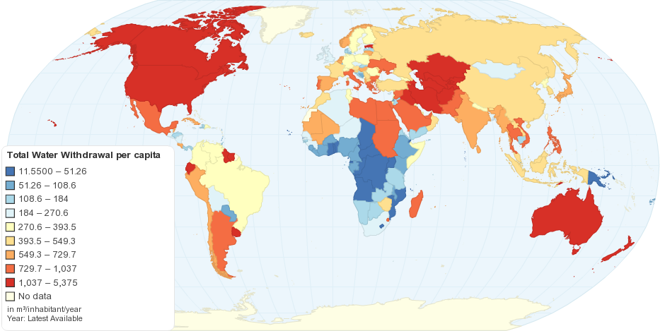
The optimal access, finally, is the consumption of an average amount of 100 liters per person of water supplied continuously through several faucets in which all the consumption and hygiene needs are met.
TOTAL WATER WITHDRAWAL PER CAPITA
In this map we can see how much water does each country withdrawal, being the african countries the first ones.
FRESHWATER RESOURCES IN EUROPE
In this table we can see a chart the freshwater resources in Europe.
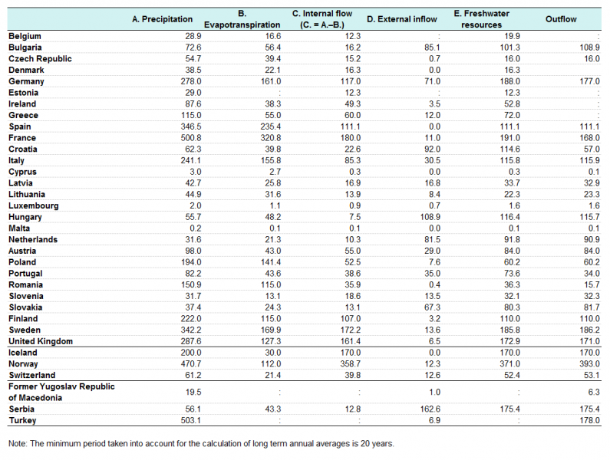
CONSEQUENCES OF WASTING WATER

Biodiversity loss | Desertification | Famine | Political conflicts | Habitats lost
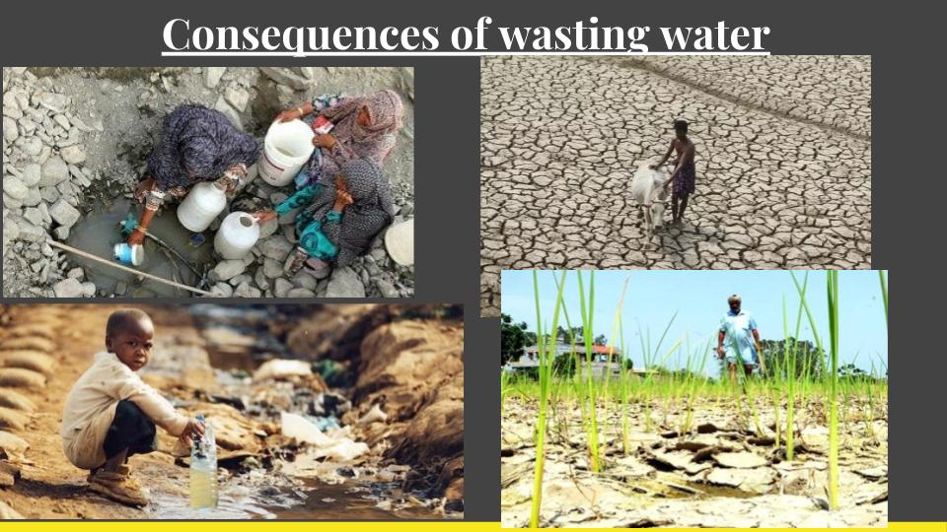

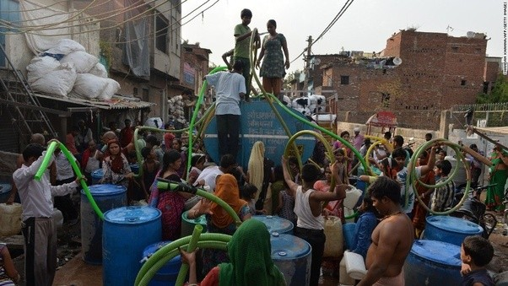

SOME TIPS TO SAVE WATER

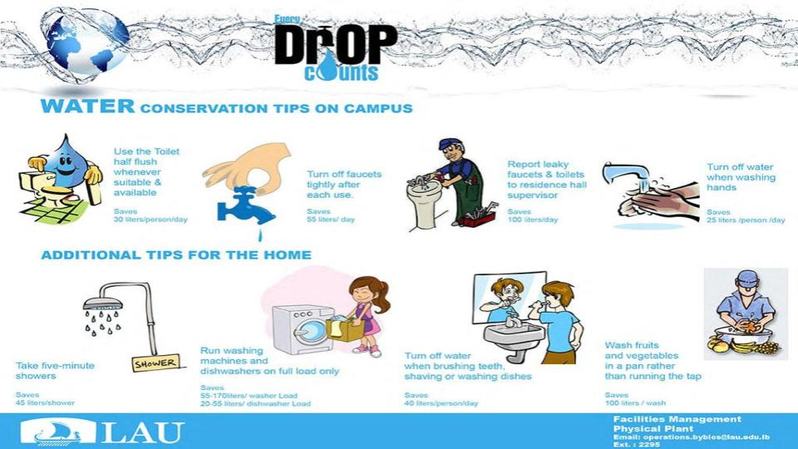
- Throw the toilet paper in the wastebasket and not in the toilet
- Use the dishwasher only when it is completely full and using a water saving program.
- Check that all faucets have water aerators.
- Showering instead of bathing
- Use thermostatic faucets
- Place systems of double discharge or interruption in toilets
PLASTIC

WORLD PLASTIC PRODUCTION FROM 1950 TO 2014

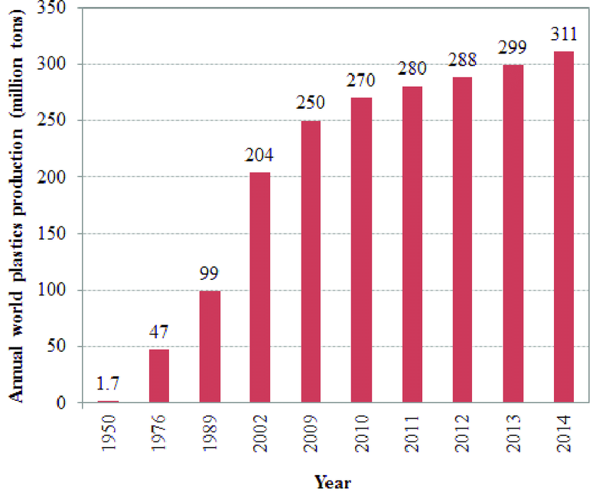
This statistic describes the worldwide plastic production from 1950 to 2014. In 2009, the plastic production was about 250 million metric tons.

CONSUMPTION PER CAPITA OF PLASTIC
- USA, 148kg
- LATIN AMERICA, 31kg
- AFRICA, 22kg
- ASIA, 27Kg
- JAPON, 116kg
- SOUTHEAST ASIAN, 24kg
- SPAIN, 68Kg

CONSEQUENCES OF THE USE OF PLASTIC

- The plastic in the environment is fragmented into tiny pieces that attract and accumulate toxic substances.
- Plastics that come in contact with food poison humans.
- They are associated with different types of cancer, for example: breast cancer, uterus, ovaries, vagina and cervix, brain cancer, leukemia, etc.
- The world population consumes one million plastic bags per minute, which means almost 1.5 trillion per day and more than 500 billons per year. It is the waste that most pollutes cities and fields, harms, animals, hinders urban drainage and rivers, contributing to floods.
- Oil is both the source of plastic production and the main source of energy, so it is very necessary. Currently there is a very small amount of it, which should not be used in excess, which is why we must reduce the production and consumption of plastic.
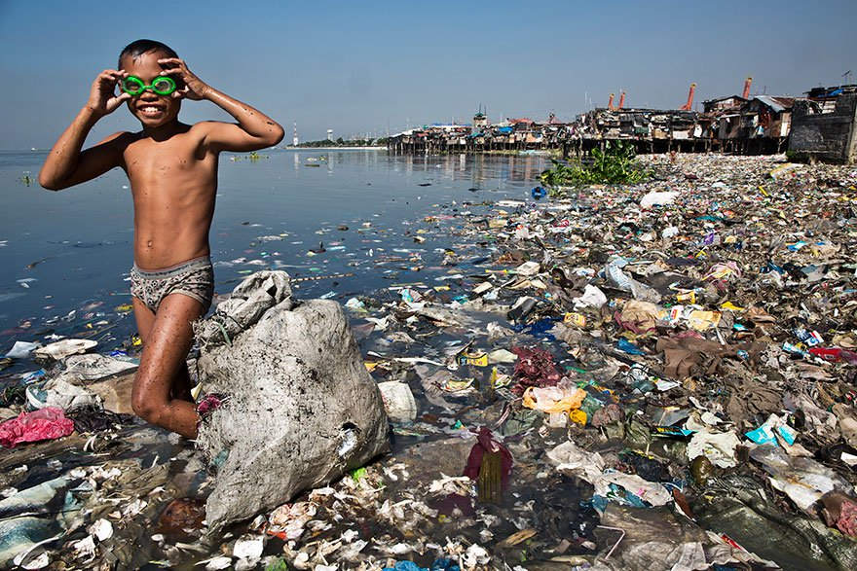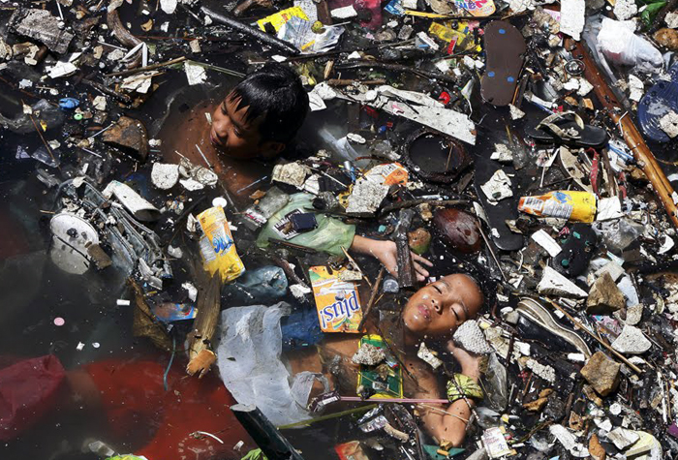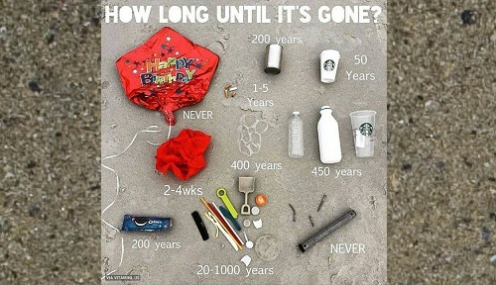
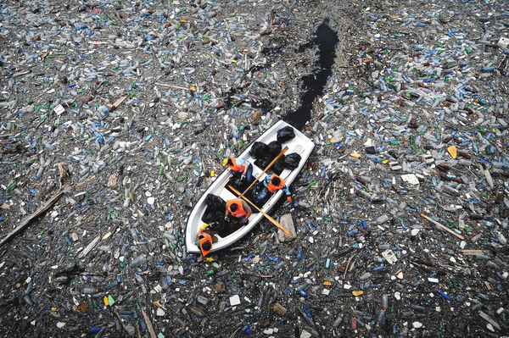
CONSEQUENCES OF THE USE OF PLASTIC IN THE SEA

- It is estimated that between 4 and 8 million tons of marine litter enter the ocean each year. Currently, there are 62 million garbage items floating in the Mediterranean.
- Plastic bags cause more than 100,000 deaths of sea turtles each year when these animals confuse them for food.
- Large debris stains occur in the oceans as there is more plastic in suspension than plankton (more plastic than food), composed of small fragments and scattered on giant surfaces (the Pacific spot is larger than the US). And due to the size of the particles it is impossible to see them with the naked eye, and less cleaning them.
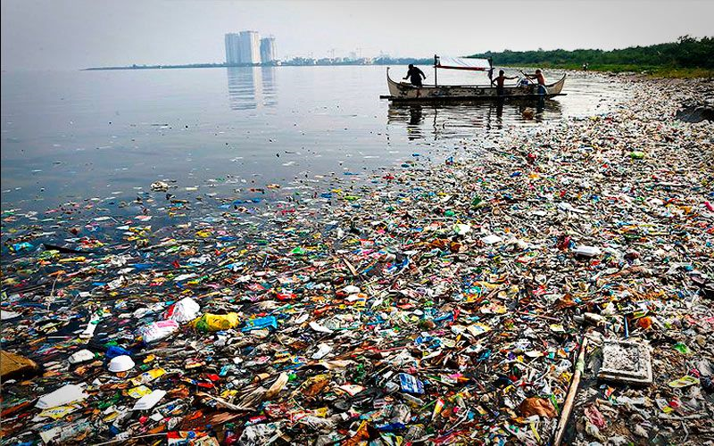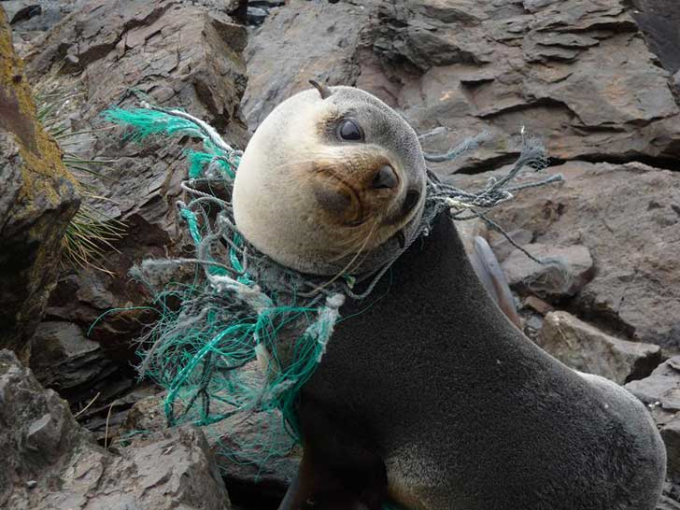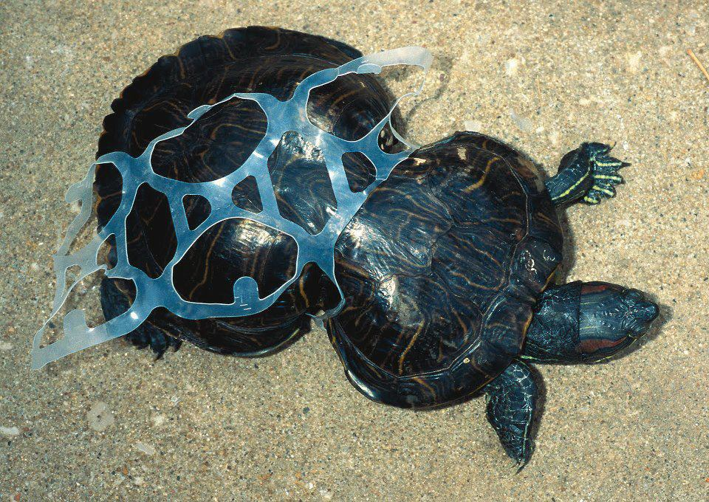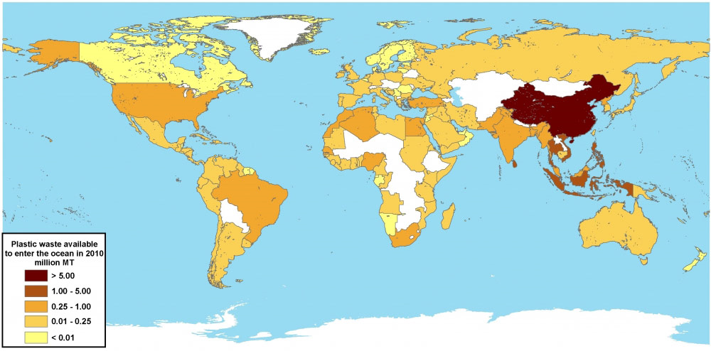
CONCLUSION / SOLUTION
As you have seen in these abominable pictures and data we must find an urgent solution to these problems, and that is why we are going to propose the following solutions:
- Giving a second use to the plastic (for example the pens made with bottle plastic).
- Using edible plastics for animals, without damaging them.
- When we go to the supermarket carry our own bags to avoid the unnecessary consumption of plastic bags.
- Stop using oil as a raw material. We can turn to new technologies such as a catalyst made with iron nanoparticles.
- Encourage the use of biodegradable plastics.
RECYCLING : REMEMBER, THE PLASTICS BELONG TO THE YELLOW CONTAINER

