MINIPROJECT from SPAIN Nº1:

EFFICIENT USAGE OF NATURAL RESOURCES

WHY DO WE NEED AN EFFICIENT USAGE OF NATURAL RESOURCES?

The growth of the economy and the increase of the population in the world mean that the Earth's natural resources are running out at high speed

Our society depends on metals, minerals, fuels, water, wood, fertile soil and clean air. However, we have been depleting these limited resources at a much faster rate than the one that allows their recovery, and if we do not change the way of acting there will be great shortages.

Our society depends on metals, minerals, fuels, water, wood, fertile soil and clean air. However, we have been depleting these limited resources at a much faster rate than the one that allows their recovery, and if we do not change the way of acting there will be great shortages.
That is why it is necessary to "use resources efficiently", that is, to generate more value by using less materials and consuming in a different way.

This will reduce the risk of scarcity, and the environmental impacts will remain within the natural limits of our planet.
THE MAIN PROBLEMS OF WASTE

The production of waste is growing all over the world. The generation of garbage brings the following environmental impacts:

- The consumption of energy and materials used to make packaging and products that we later discard.
- Water, air and ground pollution.

- All this has negative effects on human health & the environment.
This is a diagram that show how the circular economy works. The raw materials are collected, they are used in the production and sold to the consumer, after that the consumer collects it and recycles it, leading it again to the start of the process, making it a circular process.
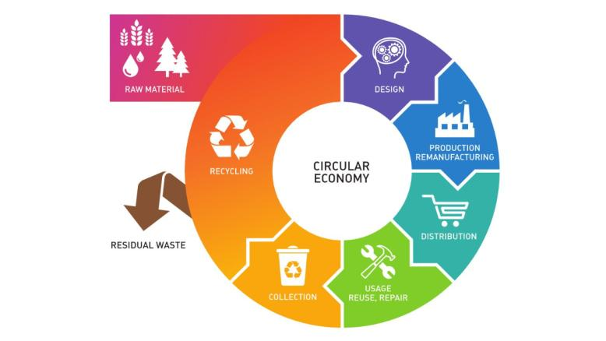
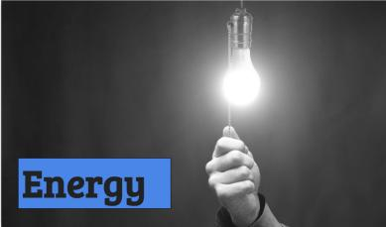 | ENERGY  We used a hand turning off a light bulb to make reference to the energy’s saving by turning off the lights.  Between 1990 and 2010, the number of people with access to electricity has increased by 1.7 billion.
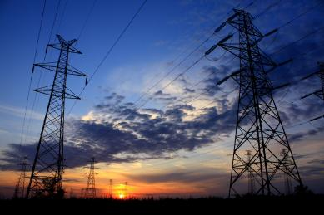 | This is a fact of the utilization of electricity since 1990, and we can observe that it has increased in 1.7 US billion people.  ENERGY - KEY FACTS  - Energy is the dominant contributor to climate change, accounting for around 60 per cent of total global greenhouse gas emission.
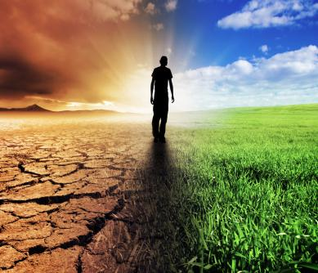 | - 3 billion people rely on wood, coal, charcoal or animal waste for cooking and heating.  - One in five people still lacks access to modern electricity.  - Reducing the carbon intensity of energy is a key objective in long-term climate goals.
These are facts about the precarious distribution of energy in the world. Here, we can see how not everyone has access to modern electricity in their house to cook or to do stuff, and how energy is a very important factor in the climate change.
SUSTAINABLE DEVELOPMENT GOALS” FROM THE UNITED NATIONS

The main global initiative on the sustainable use of energy resources is part of the Sustainable Development Goals of the United Nations
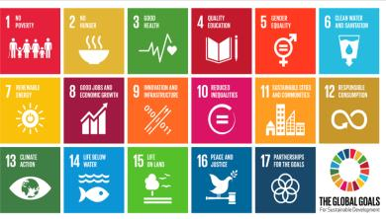 | 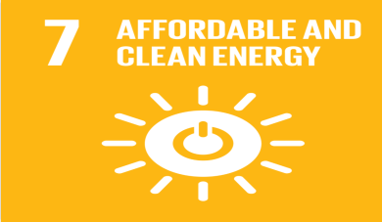
These are the objectives from the project “Sustainable Development”...and the good use of energy is one of those objectives.
TARGETS:
The targets from the point 7 Affordable and Clean energy from the project of ONU are:
- By 2030, ensure universal access to affordable, reliable and modern energy services.
- By 2030, increase substantially the share of renewable energy in the global energy mix.
- By 2030, double the global rate of improvement in energy efficiency.
- By 2030, enhance international cooperation to facilitate access to clean energy research and technology, including renewable energy, energy efficiency and advanced and cleaner fossil-fuel technology, and promote investment in energy infrastructure and clean energy technology.
We have to choose in which part of the planet we want to live.
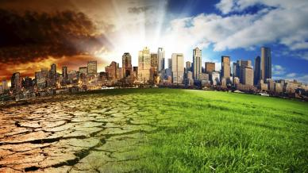 | 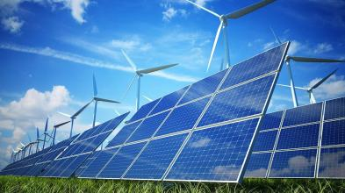
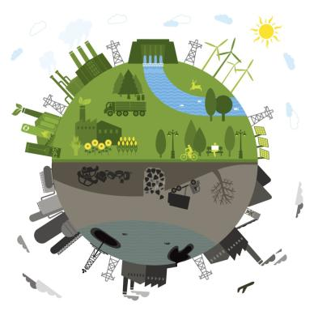 | We propose to start from our homes with a good use of energy.  No more non-renewable energies should be used because they pollute a lot and have a close limit.  Therefore, from our homes we would have to start encouraging the use of new sources of energy, for example by promoting the installation of solar panels in our urbanization.  THINGS WE CAN DO
We now show different ways to help with the change. Have a look at just a few of the many things you can do to make an impact!

- Save electricity by plugging appliances into a power strip and turning them off completely when not in use, including your computer.

- Stop paper bank statements and pay your bills online or via mobile. No paper, no need for forest destruction.

- Don’t print. See something online you need to remember? Jot it down in a notebook or better yet a digital post-it note and spare the paper.

- Turn off the lights. Your TV set or computer screen provides a cosy glow, so turn off other lights if you don’t need them.
- Do a bit of online research and buy only from companies that you know have sustainable practices and don’t harm the environment.

- Air dry. Let your hair and clothes dry naturally instead of running a machine. If you do wash your clothes, make sure the load is full.

- Take short showers. Bathtubs require gallons more water than a 5-10 minute shower.

- Eat less meat, poultry, and fish. More resources are used to provide meat than plants.
This is a good example to follow:

The Ecuadorian archipelago of the Galapagos Islands, has the first ecological airport in the world. It works through solar energy, the reuse of water and the use of wind.
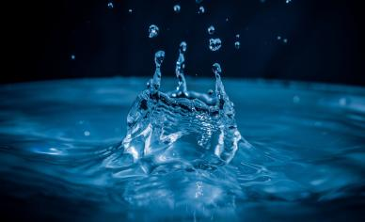 | ACTUALLY WATER CONSUMPTION  Now we’re going to show what’s the actually water consumption.  Domestic consumption of water per inhabitant is understood as the amount of water a person has for their daily consumption, cleaning, irrigation, etc.
The optimal access, finally, is the consumption of an average amount of 100 litres per person of water supplied continuously through several faucets in which all the consumption and hygiene needs are met.
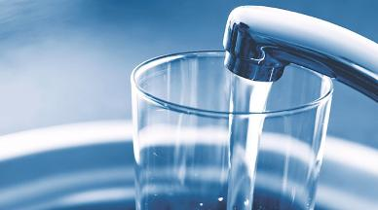
WHAT IS THE WATER CONSUMPTION PER PERSON?
In the next picture you can see the comparison from different parts of the world. Highlights the contrast between North America and Africa.
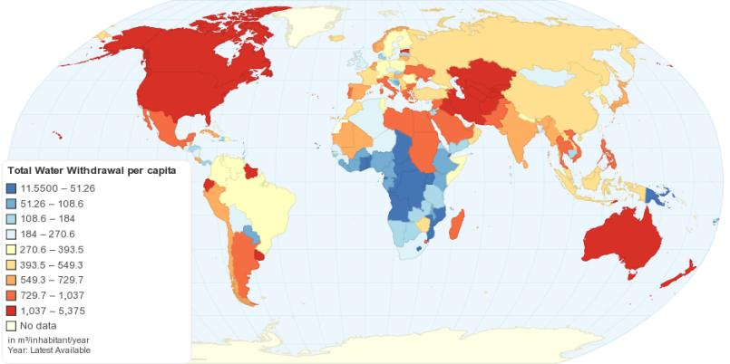
Total Water Withdrawal per capita
CONSEQUENCES OF WASTING WATER

There are some situations in which the lack of water reaches inhumane limits.
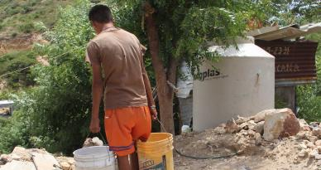 | 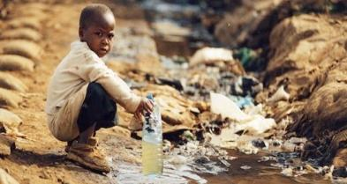
SOME TIPS FOR SAVE WATER

Here we have different tips for save the water:
- Throw the toilet paper in the wastebasket and not in the toilet.
- Use the dishwasher only when it is completely full and using a water saving program.
- Check that all faucets have water aerators.
- Showering instead of bathing.
- Use thermostatic faucets.
- Place systems of double discharge or interruption in toilets.
ZERO WASTE MOVEMENT
The main global initiative in defence of water resources is part of the Sustainable Development Goals of the United Nations.
There is the Zero Waste movement. It is a new recycle movement. It consists on the reuse of waste garbage that otherwise. They would be burned or stored. Basically to help the environment.
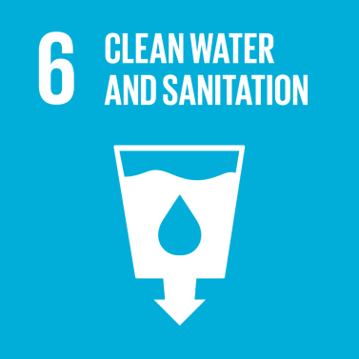 | 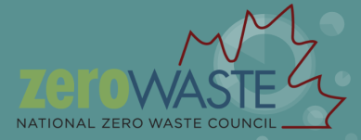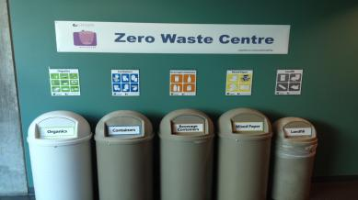
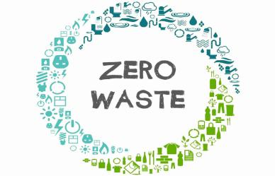 | This project try to reuse our waste in a continuous cycle.  It uses recycled products like bottles, plastic, paper, cardboards, etc… Just any rubbish that you have.  It is a good solve to erase garbage. This movement works so that the business and people work together to solve the problem of garbage.  This is Bea Johnson’s the leader of the Zero Waste movement and she was the first person in the world that made possible this project.  Some elements of a Zero Waste economy.
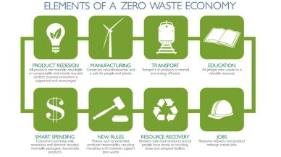 | - Jobs  - Transport  - Education  - Manufacturing  - New Rules  - Smart Spending  - Product Redesign  - Resource Recovery
Zero waste is one of the best options to fight against the climate change.
Visit: https://www.youtube.com/watch?v=KEeH4EniM3E

