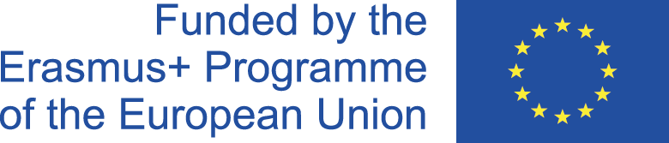
Efficent Usage of Natural resources 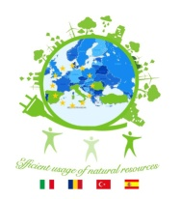
2017-1-RO01-KA219-037131

Efficient Usage of Natural Resources
Transnational Meeting Agreed Actions
Malaga, Spain – 2nd & 3rd November 2017

Organisation of the mini projects

It has been established that the mini projects will run and be coordinated according to the application form. Thus :
- First mini project: Finding ways for the efficient usage of natural resources: Italy responsible for gathering information from all participating countries (by 1st of December 2017)
- Second mini project: Finding ways for recycling – Romania responsible for gathering information by 1st of March 2018
- Third mini project: Reducing carbon footprint - Turkey is responsible for gathering information from partners by May 2018
- Fourth mini project: Photo Competition : Spain is responsible for gathering information from partners (Sept. 2018- Feb. 2019)
- Fifth mini project: Shooting a short movie: Turkey 2019

Timetable of the next LTTA and TPM

It has been established that all partner countries will bring 4 students/country at all LTTA (as written in the application form) and they will be hosted in hosting families.
Dates for the next LTTA and TPM have been established, thus:
- Italy LTTA: 4th-10th February 2018
- Romania LTTA: 27th May-2nd June 2018
- Romania TPM: 9th-13th September 2018

What has been done
- Logo competition and selection in every partner school and at internation level (TPM, Malaga, Spain) . The logo of the project is:

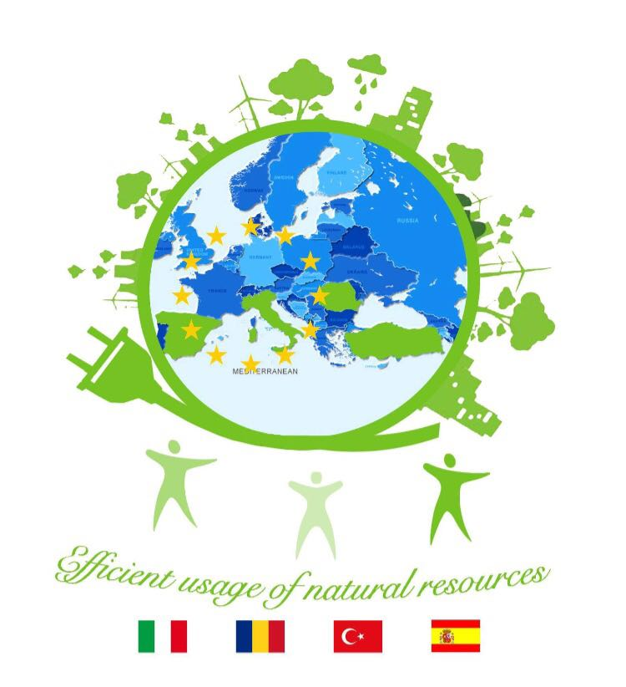
- Website of the project: http://eco-partners.weebly.com
- Partnerships with different institutions from the partner countries: universities, Botanical gardens, Environmental NGO-s, local authorities, etc
- Facebook Page: https://www.facebook.com/racovitaromania/
- Facebook closed group

Further Actions

- All partner countries are to send to the coordinator (Romania) a feed back about the website of the project by 15th of November 2017
- Creation of a Twin Space : Italy responsible (by 15th of November 2017)
- Test about Environment Awareness (Environmental Bahaviour Scale) to be taken by all students involved in the project (by 1st of December 2017)
- Creation of the Edmodo Class : Turkey responsible by 1st of
December 2017?
- Organising flash mobs at the same time in all partner countries (Romania responsible)

